Quiz #2

1. **Which layer in the backpropagation algorithm is utilized for adjusting weights?**

a - Input layer

b - Hidden layer

c - Intermediate layer

d - Output layer

1. **How can we calculate the error in backpropagation?**

a - Calculate the difference between the true value and the predicted value.

b - Calculate the cross-entropy error.

c - Calculate the mean square error (MSE).

d - Calculates the distance between the predicted value and the actual value of the model.

1. **Choose the correct order of the backpropagation.**

|  |
| --- |
| 1. Feed the training sample 2. Backpropagate the weights, biases 3. Initialize the weights, biases 4. Propagate the inputs forward 5. Backpropagate the error |

a - 13425

b - 34125

c - 31452

d - 32435

e - 14352

1. **Choose the correct description for gradient descent.**

a - After each iteration, we modify the weight vector in the direction of the gradient.

b - In the gradient descent algorithm each update of the weight vector depends on all the training examples.

c - We have to choose a non-variable learning rate.

d - After each iteration, we modify the weight vector in the direction of the negative gradient.

1. **In this case, how can we calculate $\frac{∂Cx}{∂w41}$?**

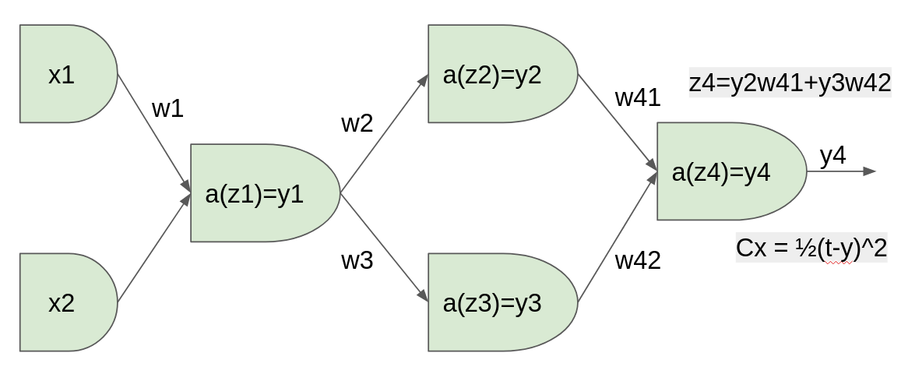

a - $\frac{∂Cx}{∂z2}$・ $\frac{∂z2}{∂y3}$・ $\frac{∂y3}{∂z4}$・ $\frac{∂z4}{∂w41}$

b - $\frac{∂Cx}{∂y4}$・ $\frac{∂y4}{∂y3}$・ $\frac{∂y3}{∂z4}$・ $\frac{∂z4}{∂w41}$

c - $\frac{∂Cx}{∂y4}$・ $\frac{∂y4}{∂y3}$・ $\frac{∂y3}{∂w41}$

d - $\frac{∂Cx}{∂y4}$・ $\frac{∂y4}{∂z4}$・ $\frac{∂z4}{∂w41}$